The Way

Aesthetic Portfolio

Version <1.0>

Submit Date<25 Nov 2017>

Revision History
Date | Version | Description | Author
<25 NOV 2017> | <1.0> | Aesthetic Portfolio | Cris Kamurai

Table of Contents
Page

1. Introduction 4

1.1 Purpose 4

1.2 Scope 4

1.4 References 4

2. Background Listings 4

3. Sprite Listings 4
3.1 Game Objects 5
3.1.A Board Objects 5
3.1.B Tile Objects 6
3.1.C Token Objects 6
3.1.D Card Objects 6
First Edition Cards 7
Second Edition Cards 25
3.2 Menu Objects 34
3.3 Interface Objects 34
3.4 Title Objects 34

4. Room Designs 35

4.1 Preface 35

4.2 Key 35

4.3 Layouts 35

5. Supporting Information 35
Appendix 36
Index 42

Aesthetic Portfolio

1. Introduction
<State what this document is and related documents.>

This document is designed to give a basic explanation of the aesthetics involved in the project.

Purpose
<State the purpose of this document and what information it is supposed to provide.>

The purpose of this document is to demonstrate the pictures that make up the thematic look of The Way board game.

Scope
<This section should list the goals, and priorities of what is to be accomplished in this document.>

The scope of this document is to explain all of the available pictures and art for the The Way board game.

References
<This section should list references to information sources outside the creative properties of the authors>

2. Background Listings
<This section should contain a full listing, possibly divided into sub categories, of backgrounds that are to be used for each screen designed in the game.>

N/A: there are currently no applicable backgrounds for The Way.

3. Sprite Listings
<This section should contain a full listing, possibly divided into sub categories, of sprites, to include images and full descriptions of their uses.>

3.1 Game Objects
<This section should include all objects that are used for actual game play interactions. i.e. characters, enemies, terrain.>

3.1.A Board Objects

Main Board:
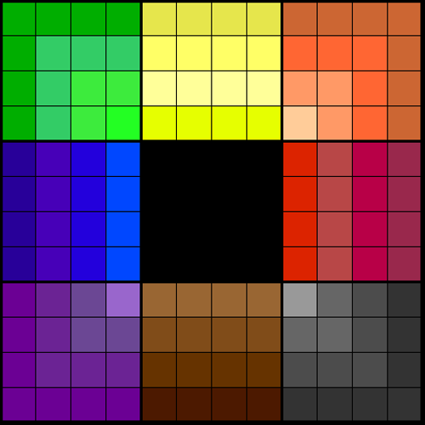

3.1.B Tile Objects

N/A: there are currently no applicable Tile Objects for The Way.

3.1.C Token Objects

Generic pawns or meeples may be used to represent player pieces at this time.

3.1.D Card Objects

Card Backing:
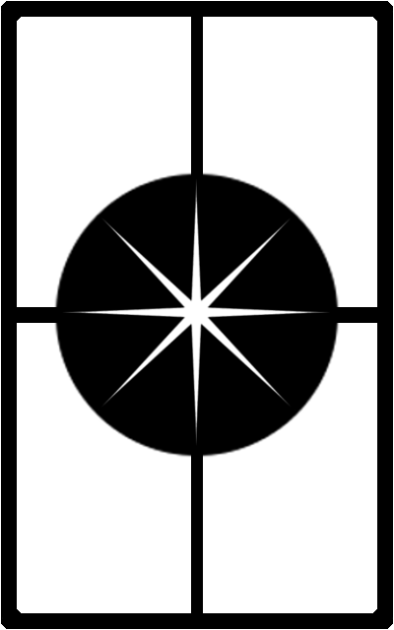

First Edition Cards:
Target 1, Move 1, Air:
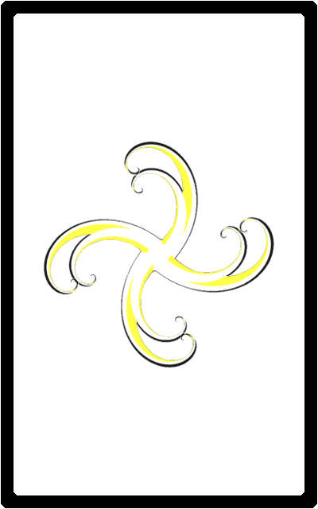
Target 1, Move 1, Earth:

Target 1, Move 1, Fire:

Target 1, Move 1, Water:

Target 1, Move 1, Wild:
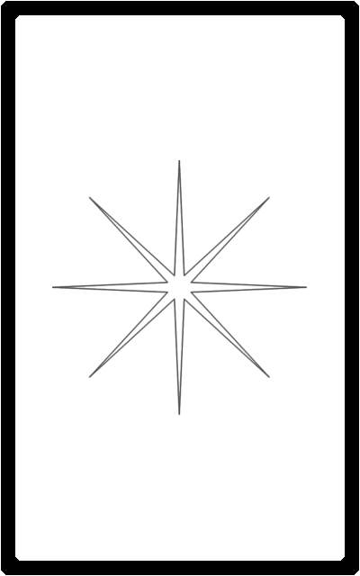
Target 1, Move 2, Air:
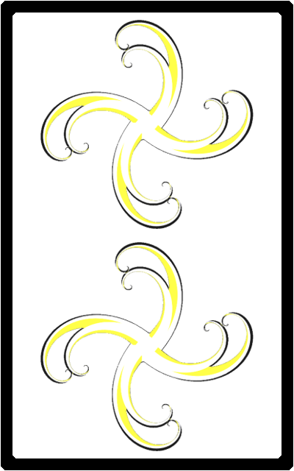
Target 1, Move 2, Earth:
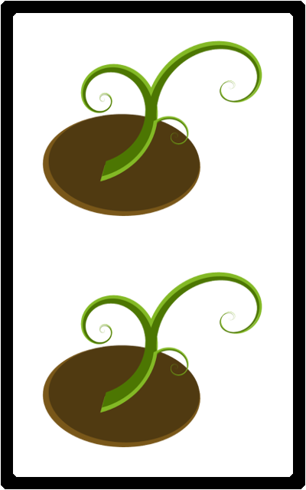
Target 1, Move 2, Fire:

Target 1, Move 2, Water:

Target 1, Move 2, Wild:
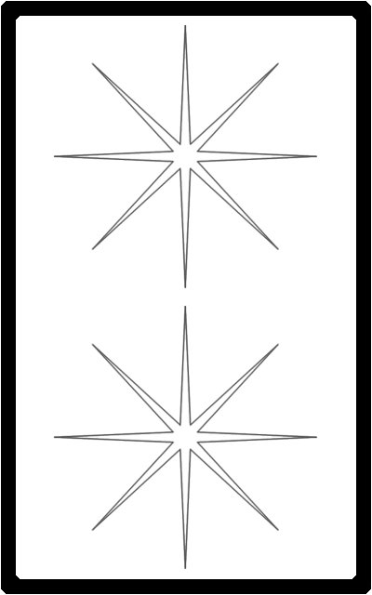
Target 2, Move 1 Air, Air:
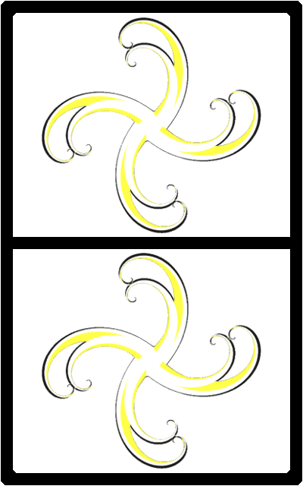
Target 2, Move 1, Air, Earth:
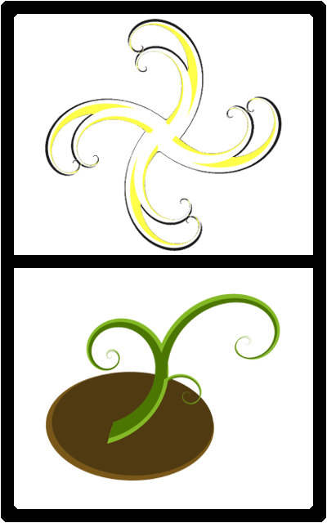
Target 2, Move 1, Air, Fire:
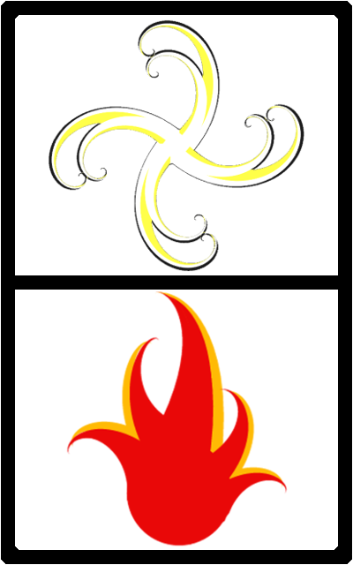
Target 2, Move 1, Air, Water:
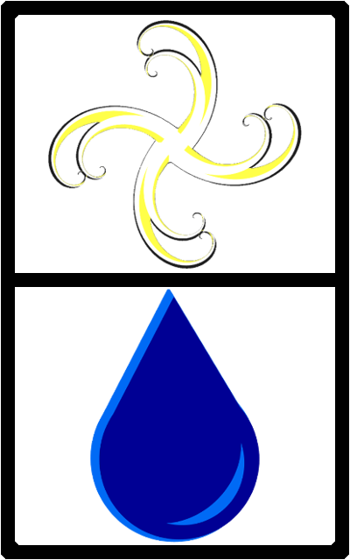
Target 2, Move 1, Air, Wild:
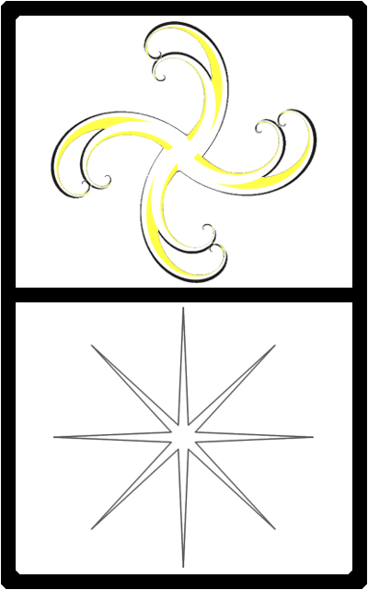
Target 2, Move 1 Earth, Air:
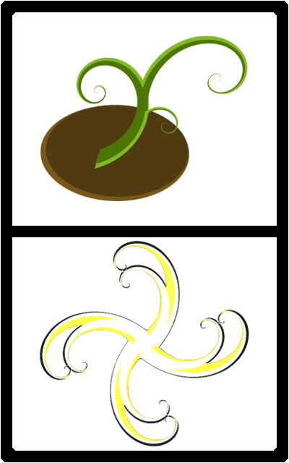
Target 2, Move 1, Earth, Earth:
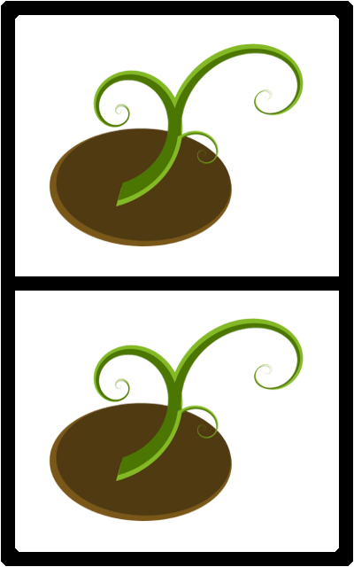
Target 2, Move 1, Earth, Fire:
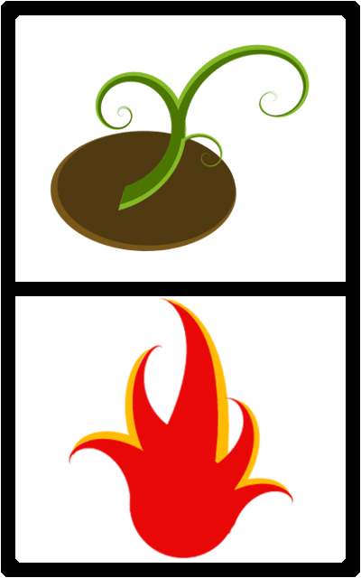
Target 2, Move 1, Earth, Water:
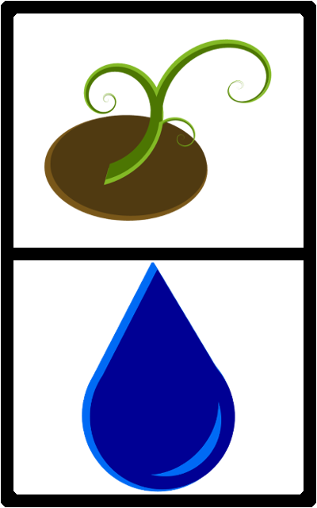
Target 2, Move 1, Earth, Wild:
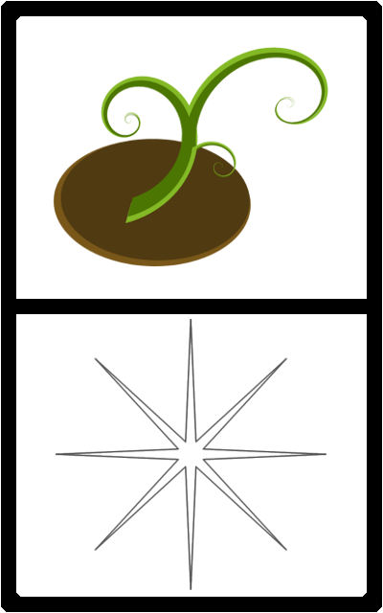
Target 2, Move 1 Fire, Air:
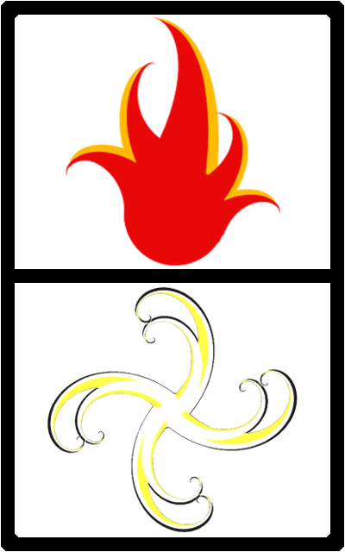
Target 2, Move 1, Fire, Earth:
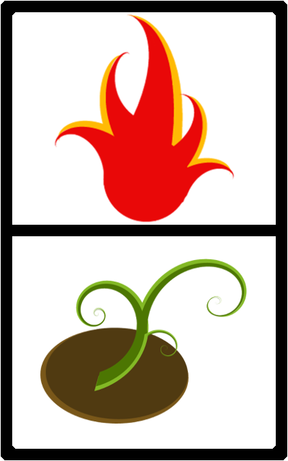
Target 2, Move 1, Fire, Fire:
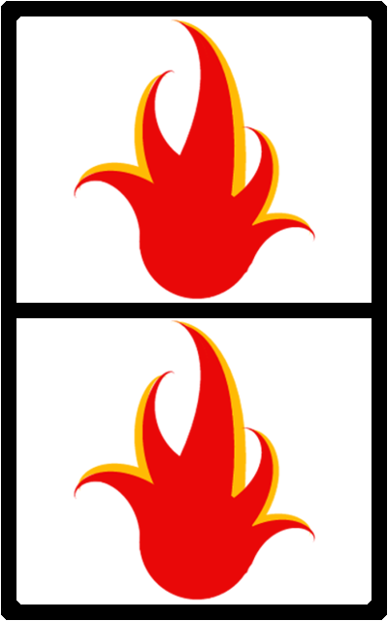
Target 2, Move 1, Fire, Water:
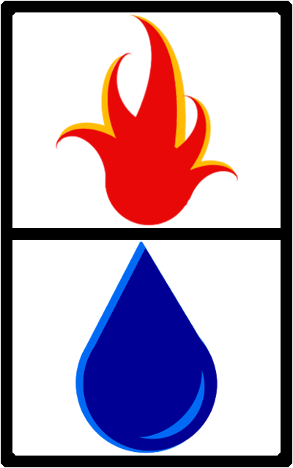
Target 2, Move 1, Fire, Wild:
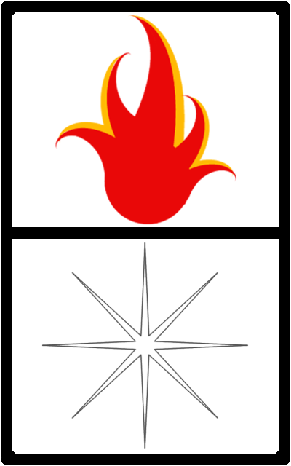
Target 2, Move 1 Water, Air:
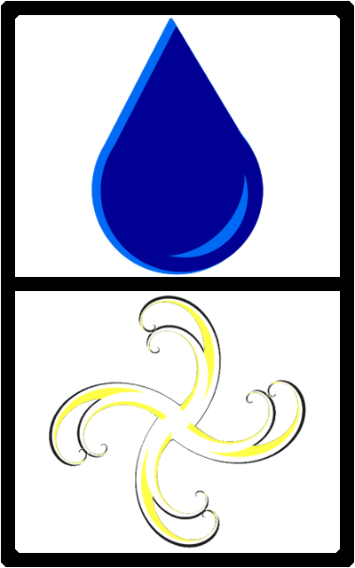
Target 2, Move 1, Water, Earth:
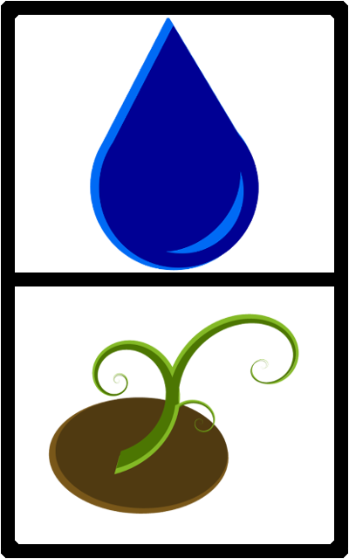
Target 2, Move 1, Water, Fire:

Target 2, Move 1, Water, Water:
Target 2, Move 1, Water, Wild:

Target All, Move 1, Air:
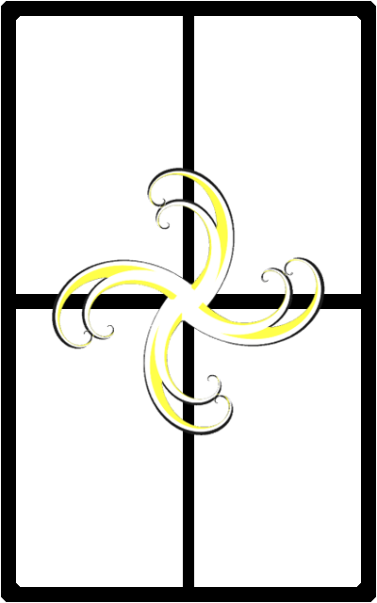
Target All, Move 1, Earth:
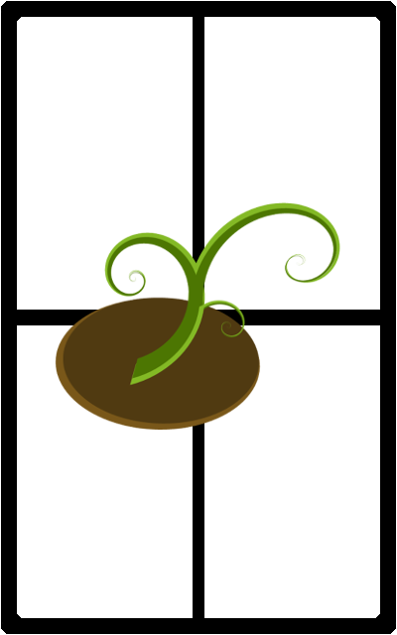
Target All, Move 1, Fire:

Target All, Move 1, Water:
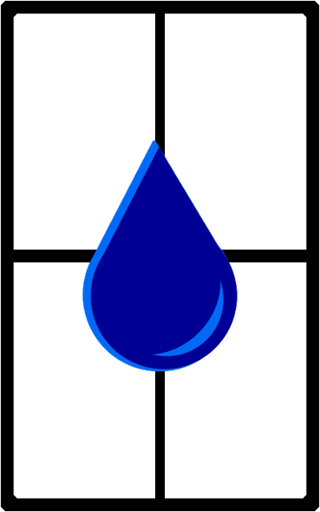
Target All, Move 1, Wild:
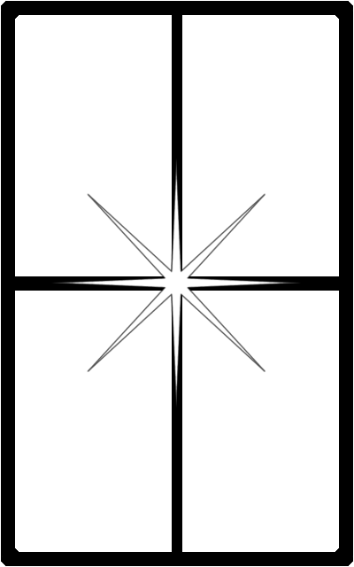
Second Edition Cards:
Target 1, Move 1, Void:

Target 2, Move 1, Air, Void:
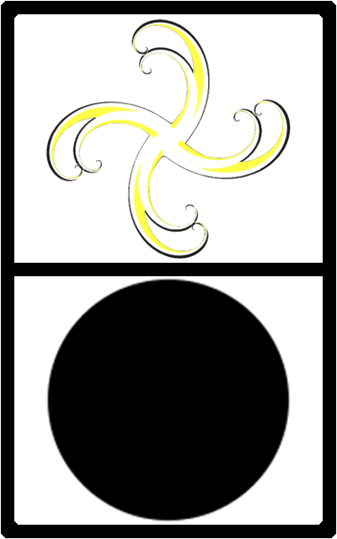
Target 2, Move 1, Earth, Void:
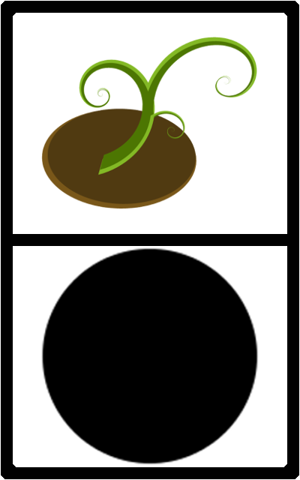
Target 2, Move 1, Fire, Void:

Target 2, Move 1, Void, Air:
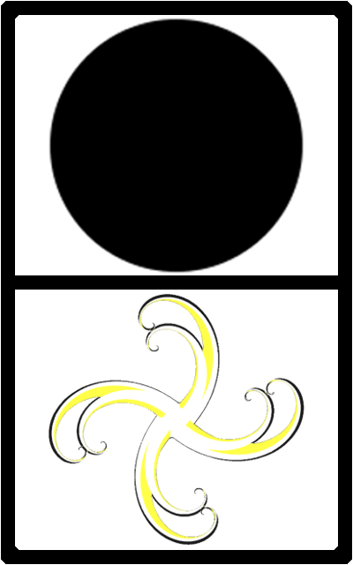
Target 2, Move 1, Void, Earth:

Target 2, Move 1, Void, Fire:

Target 2, Move 1, Void, Void:
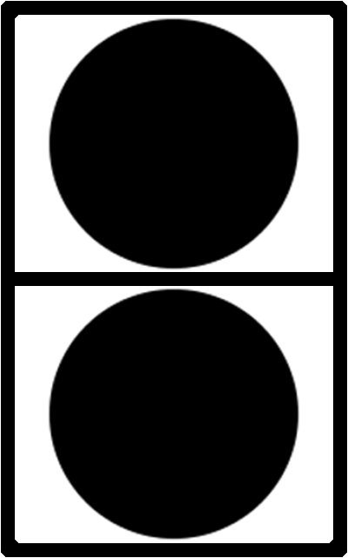
Target 2, Move 1, Void, Water:

Target 2, Move 1, Void, Wild:

Target 2, Move 1, Water, Void:

Target 2, Move 1, Wild, Air:
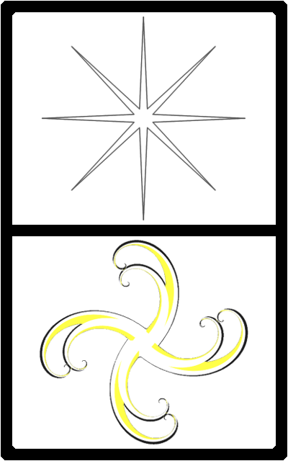
Target 2, Move 1, Wild, Earth:
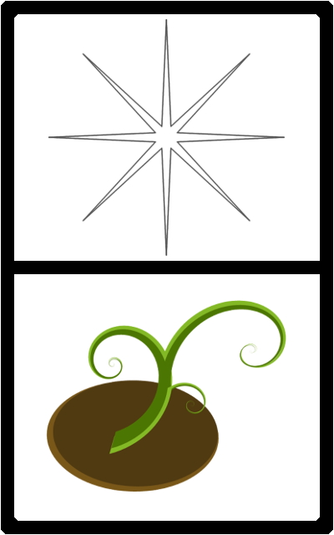
Target 2, Move 1, Wild, Fire:
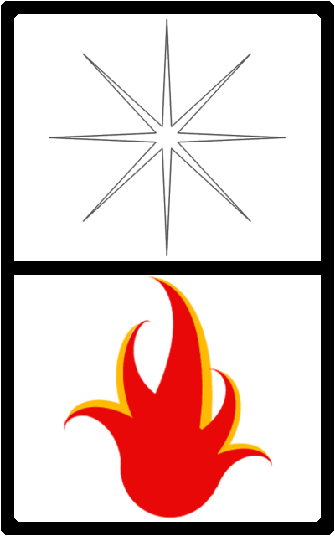
Target 2, Move 1, Wild, Void:
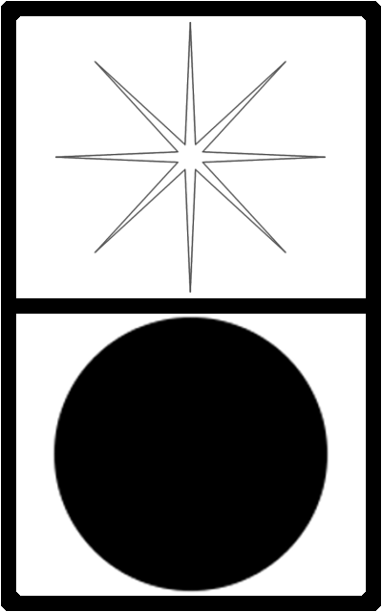
Target 2, Move 1, Wild, Water:
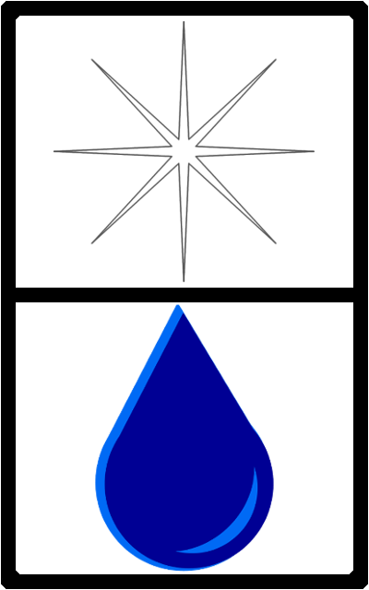
Target 2, Move 1, Wild, Wild:
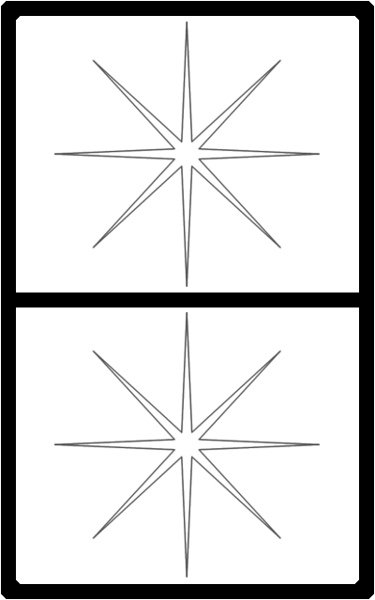
Target All, Move 1, Void:
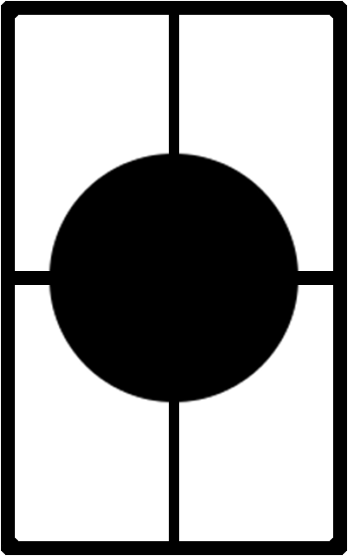

3.2 Menu Objects
<This section should include all objects that are used for in-game Menus, to include Command Bars and HUDs.>

N/A: there are currently no applicable Menu Objects for The Way.

3.3 Interface Objects
<This section should be for all objects that are not part of game play, but assist with game functionality, e.g. a display window.>

N/A: there are currently no applicable Interface Objects for The Way.

3.4 Title Objects
<This section may be used for all objects that occur before actual game play begins.>

Title Logo:


4. Room Designs
<This section should be used for designs (blueprints) for the game navigable areas.>

N/A: There are currently no room designs for The Way.

4.1 Preface
<This section should contain the idea behind this design, and what is required to meet its needs.>

N/A: There are currently no room prefaces for The Way.

4.2 Key
<The designs should follow a common key, and display that key.>

N/A: There are currently no room keys for The Way.

4.3 Layouts
<This section should be used to list the designs for game navigable areas.>

N/A: There are currently no room layouts for The Way.

5. Supporting Information
<Any further information or locations at which further information may be obtained may be listed here.>

Appendix:
<Additional documentation that does not warrant an entirely separate document may be listed here.>
Symbols:
Air:


Earth:


Fire:


Void:.


Water:


Wild:


Index
Page
Table of Contents 3

1. Introduction 4

1.1 Purpose 4

1.2 Scope 4

1.4 References 4

2. Background Listings 4

3. Sprite Listings 4
3.1 Game Objects 5
3.1.A Board Objects 5
3.1.B Tile Objects 6
3.1.C Token Objects 6
3.1.D Card Objects 6
First Edition Cards 7
Second Edition Cards 25
3.2 Menu Objects 34
3.3 Interface Objects 34
3.4 Title Objects 34

4. Room Designs 35

4.1 Preface 35

4.2 Key 35

4.3 Layouts 35

5. Supporting Information 35
Appendix 36

